**Market Research Websites and Resources**

* [**North_America_Whey_Protein_Ingredients_Market_1713958137553.pdf (mordorintelligence.com)**](https://lorien-live.mordorintelligence.com/samples/90086/North_America_Whey_Protein_Ingredients_Market_1713958137553.pdf?leadId=6710634966f4b6dea2d12706)
* [**BLS Data Viewer**](https://data.bls.gov/dataViewer/view/timeseries/CXU620111LB1103M)
* [**Whey Protein benefits, dosage, and side effects (examine.com)**](https://examine.com/supplements/whey-protein/?show_conditions=true#examine-database)
* [**Publication : USDA ARS**](https://www.ars.usda.gov/research/publications/publication/?seqNo115=209388)

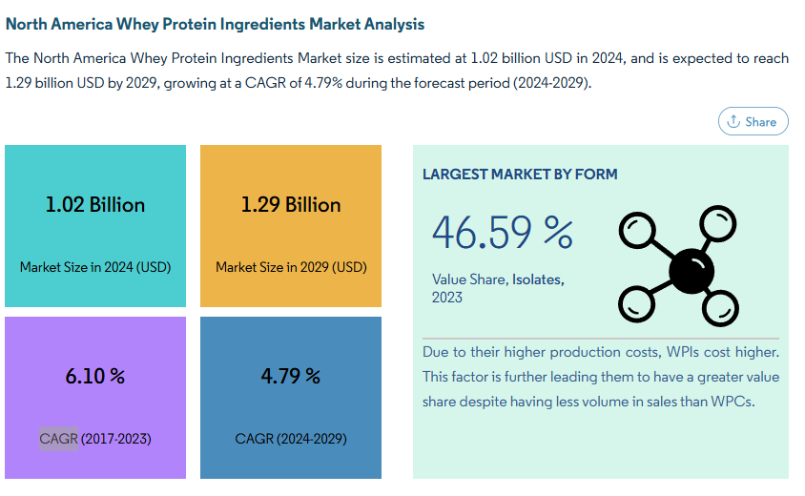

[North_America_Whey_Protein_Ingredients_Market_1713958137553.pdf (mordorintelligence.com)](https://lorien-live.mordorintelligence.com/samples/90086/North_America_Whey_Protein_Ingredients_Market_1713958137553.pdf?leadId=6710634966f4b6dea2d12706)A graph of blue bars
